How to read content of list?
The content of list can be read in different ways
- Indexing
- Slicing
- For loop
- Iterator
- Enumerate

Note: The content of any sequence is read using above 5 approaches

Indexing

What is index?
Index is an integer value, which represent value location
Every location or value in list or sequence is identified with unique number called index.
This index can be used to data sequentially or randomly.
This index is used as a subscript to read data from sequence or list.

Syntax: list-name[index] (OR) sequence-name[index]

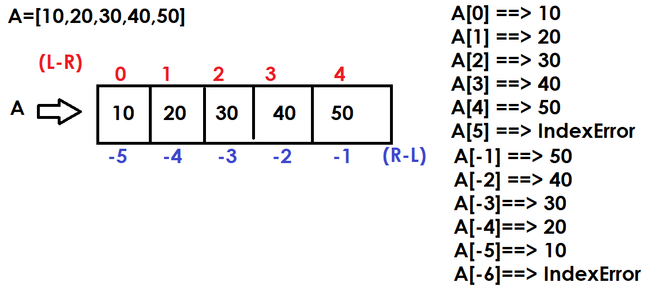

Example:
# Reading values from list using index  A=[10,20,30,40,50]  print(A[0],A[1],A[2],A[3],A[4])  print(A[-1],A[-2],A[-3],A[-4],A[-5])  print("Left to Right")  for i in range(5):  print(A[i])  print("Right to Left")  for i in range(-1,-6,-1):  print(A[i])  print("Right to Left")  for i in range(4,-1,-1):  print(A[i])  print("Left to Right")  for i in range(-5,0):  print(A[i]) | Output  10 20 30 40 50  50 40 30 20 10  Left to Right  10  20  30  40  50  Right to Left  50  40  30  20  10  Right to Left  50  40  30  20  10  Left to Right  10  20  30  40  50

len() : it predefined function in python. This returns count of values exists within collection (sequences,sets or mapping).

Syntax: len(iterable/collection)

>>> A=[10,20,30]
>>> len(A)
3
>>> B=[10,20,30,40,50,60]
>>> len(B)
6

# Write a program to sum of values or elements or items of list

A=[10,70,20,80,11,36,87,34,10,67,83,20]

s=0
for i in range(len(A)):
s=s+A[i]

print(f'List is {A}')
print(f'Sum of Elements of list {s}')

Output
List is [10, 70, 20, 80, 11, 36, 87, 34, 10, 67, 83, 20]
Sum of Elements of list 528

Example:
# Write a program to count even and odd numbers exists within
# list

A=[7,10,48,14,56,78,98,34,54,76,45,52,35,59,13,7,9,3]

ec=0
oc=0
for i in range(len(A)):
if A[i]%2==0:
ec+=1
else:
oc+=1

print(f'List is {A}')
print(f'Even Numbers Count {ec}')
print(f'Odd Numbers Count {oc}')

Output
List is [7, 10, 48, 14, 56, 78, 98, 34, 54, 76, 45, 52, 35, 59, 13, 7, 9, 3]
Even Numbers Count 10
Odd Numbers Count 8

Slicing
Slicing is a process of reading multiple elements or values from sequence. Slicing generates multiple indexes to reading more than one value.

What is difference between indexing and slicing?
Indexing accesses a single element using its specific position (index), while slicing extracts a sequence (or subset) of elements using a range of indices. Indexing returns one item, whereas slicing always returns a new sequence (e.g., a new list, string, or tuple) of the same type as the original, even if only one element is retrieved.

How to slicing is done?
Slicing is done using 2 approaches
- Using slice operator
- Using slice object

Slice operator or slice object generates multiple indexes to read multiple values.

Slice operator
Slice operator generates multiple indexes to read multiple values

Syntax: sequence-name[start-index:stop-index:step]

Internally slice operator uses range for generating multiple indexes

Example:  A=[10,20,30,40,50,60,70,80,90,100]  print(A)  B=A[0:5:1]  print(B)  C=A[5:10:1]  print(C)  D=A[0:10:2]  print(D)  E=A[1:10:2]  print(E)  F=A[0:10:1]  print(F)  G=A[-1:-6:-1]  print(G)  H=A[-6:-11:-1]  print(H)  I=A[-1:-11:-1]  print(I)  J=A[-1:-11:-2]  print(J) | Output  [10, 20, 30, 40, 50, 60, 70, 80, 90, 100]  [10, 20, 30, 40, 50]  [60, 70, 80, 90, 100]  [10, 30, 50, 70, 90]  [20, 40, 60, 80, 100]  [10, 20, 30, 40, 50, 60, 70, 80, 90, 100]  [100, 90, 80, 70, 60]  [50, 40, 30, 20, 10]  [100, 90, 80, 70, 60, 50, 40, 30, 20, 10]  [100, 80, 60, 40, 20]

Syntax-1: sequence-name[::] (OR) sequence[:]
In this syntax default start=0,stop=len(sequence),step=1
This syntax create copy of sequence by reading all the elements from left to right.

Example:
A=list(range(10,110,10))
print(A)
B=A[::]
print(B)
C=A[:]
print(C)

Output
[10, 20, 30, 40, 50, 60, 70, 80, 90, 100]
[10, 20, 30, 40, 50, 60, 70, 80, 90, 100]
[10, 20, 30, 40, 50, 60, 70, 80, 90, 100]

Syntax-2: sequence-name[::step]
In this syntax start,stop values are taken based on step value
If step is +ve, start=0,stop=len(sequence)
If step is –ve, start=-1,stop=-len(sequence)

Example:
A=list("PROGRAMMING")
print(A)
B=A[::1]
print(B)
C=A[::2]
print(C)
D=A[::-1]
print(D)
E=A[::-2]
print(E)

Output
['P', 'R', 'O', 'G', 'R', 'A', 'M', 'M', 'I', 'N', 'G']
['P', 'R', 'O', 'G', 'R', 'A', 'M', 'M', 'I', 'N', 'G']
['P', 'O', 'R', 'M', 'I', 'G']
['G', 'N', 'I', 'M', 'M', 'A', 'R', 'G', 'O', 'R', 'P']
['G', 'I', 'M', 'R', 'O', 'P']

Syntax3: sequence-name[start:stop]
In this syntax default step value is 1

Example:
A=[10,20,30,40,50,60,70,80,90,100]
print(A)
B=A[3:8]
print(B)
C=A[3:-3]
print(C)
D=A[2:-2]
print(D)

Output
[10, 20, 30, 40, 50, 60, 70, 80, 90, 100]
[40, 50, 60, 70, 80]
[40, 50, 60, 70]
[30, 40, 50, 60, 70, 80]

Syntax-4: sequence-name[start::] (OR) sequence-name[start:]
In this syntax default step is 1 and stop till end of the sequence
This syntax read elements from left to right

Example:
A=[10,20,30,40,50,60,70,80,90,100]
print(A)
B=A[3:]
print(B)
C=A[-5:]
print(C)

Output
[10, 20, 30, 40, 50, 60, 70, 80, 90, 100]
[40, 50, 60, 70, 80, 90, 100]
[60, 70, 80, 90, 100]

Syntax-5: sequence-name[:stop:]
In this syntax default start=0,step=1

A=[10,20,30,40,50,60,70,80,90,100]
print(A)
B=A[:5]
print(B)
C=A[:-5]
print(C)

Output
[10, 20, 30, 40, 50, 60, 70, 80, 90, 100]
[10, 20, 30, 40, 50]
[10, 20, 30, 40, 50]

